Tom Clancy's HAWX

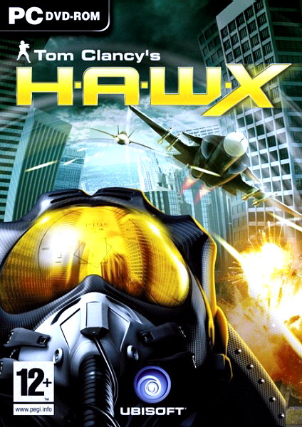

Year: 2009
Genre: Arcade / Flight Combat / 3D
Developer: Ubisoft Bucharest
Publisher: Ubisoft Entertainment
Platform: PC
Operating System: Microsoft ® Windows ® XP SP2 (rus) / Vista
Processor: Intel ® Core 2 Duo 2 GHz
Memory: 1 GB (2048 MB for Windows Vista)
Video Card: 256 MB memory, compatible with DirectX ® 9.0s
Sound Card: compatible with DirectX ® 9.0c
Device control: Keyboard, Mouse
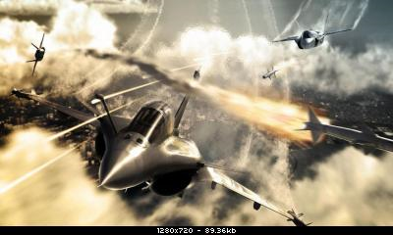
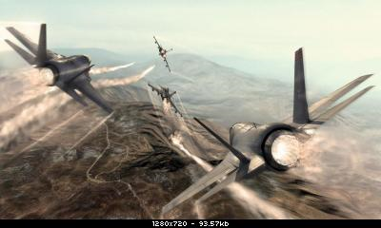

Download links:
100mb
http://rapidshare.co...Forum.com.part01.rar
http://rapidshare.co...Forum.com.part02.rar
http://rapidshare.co...Forum.com.part03.rar
http://rapidshare.co...Forum.com.part04.rar
http://rapidshare.co...Forum.com.part05.rar
http://rapidshare.co...Forum.com.part06.rar
http://rapidshare.co...Forum.com.part07.rar
http://rapidshare.co...Forum.com.part08.rar
http://rapidshare.co...Forum.com.part09.rar
http://rapidshare.co...Forum.com.part10.rar
http://rapidshare.co...Forum.com.part11.rar
http://rapidshare.co...Forum.com.part12.rar
http://rapidshare.co...Forum.com.part13.rar
http://rapidshare.co...Forum.com.part14.rar
http://rapidshare.co...Forum.com.part15.rar
http://rapidshare.co...Forum.com.part16.rar
http://rapidshare.co...Forum.com.part17.rar
http://rapidshare.co...Forum.com.part18.rar
http://rapidshare.co...Forum.com.part19.rar
http://rapidshare.co...Forum.com.part20.rar
http://rapidshare.co...Forum.com.part21.rar
http://rapidshare.co...Forum.com.part22.rar
http://rapidshare.co...Forum.com.part23.rar
http://rapidshare.co...Forum.com.part24.rar
http://rapidshare.co...Forum.com.part25.rar
http://rapidshare.co...Forum.com.part26.rar
http://rapidshare.co...Forum.com.part27.rar
http://rapidshare.co...Forum.com.part28.rar
http://rapidshare.co...Forum.com.part29.rar
http://rapidshare.co...Forum.com.part30.rar
http://rapidshare.co...Forum.com.part31.rar
http://rapidshare.co...Forum.com.part32.rar
http://rapidshare.co...Forum.com.part33.rar
http://rapidshare.co...Forum.com.part34.rar
http://rapidshare.co...Forum.com.part35.rar
http://rapidshare.co...Forum.com.part36.rar
http://rapidshare.co...Forum.com.part37.rar
http://rapidshare.co...Forum.com.part38.rar
100mb
http://www.netload.i...m.com.part01.rar.htm
http://www.netload.i...m.com.part02.rar.htm
http://www.netload.i...m.com.part03.rar.htm
http://www.netload.i...m.com.part04.rar.htm
http://www.netload.i...m.com.part05.rar.htm
http://www.netload.i...m.com.part06.rar.htm
http://www.netload.i...m.com.part07.rar.htm
http://www.netload.i...m.com.part08.rar.htm
http://www.netload.i...m.com.part09.rar.htm
http://www.netload.i...m.com.part10.rar.htm
http://www.netload.i...m.com.part11.rar.htm
http://www.netload.i...m.com.part12.rar.htm
http://www.netload.i...m.com.part13.rar.htm
http://www.netload.i...m.com.part14.rar.htm
http://www.netload.i...m.com.part15.rar.htm
http://www.netload.i...m.com.part16.rar.htm
http://www.netload.i...m.com.part17.rar.htm
http://www.netload.i...m.com.part18.rar.htm
http://www.netload.i...m.com.part19.rar.htm
http://www.netload.i...m.com.part20.rar.htm
http://www.netload.i...m.com.part21.rar.htm
http://www.netload.i...m.com.part22.rar.htm
http://www.netload.i...m.com.part23.rar.htm
http://www.netload.i...m.com.part24.rar.htm
http://www.netload.i...m.com.part25.rar.htm
http://www.netload.i...m.com.part26.rar.htm
http://www.netload.i...m.com.part27.rar.htm
http://www.netload.i...m.com.part28.rar.htm
http://www.netload.i...m.com.part29.rar.htm
http://www.netload.i...m.com.part30.rar.htm
http://www.netload.i...m.com.part31.rar.htm
http://www.netload.i...m.com.part32.rar.htm
http://www.netload.i...m.com.part33.rar.htm
http://www.netload.i...m.com.part34.rar.htm
http://www.netload.i...m.com.part35.rar.htm
http://www.netload.i...m.com.part36.rar.htm
http://www.netload.i...m.com.part37.rar.htm
http://www.netload.i...m.com.part38.rar.htm

